**Title Page**

Acknowledging the Improved Rate in Colon Cancer Detection Using RNN vs CNN Algorithms

Akmal Mohammed Taufeeq A,

Research scholar,

Department of Information Technology,

Saveetha school of Engineering,

Saveetha Institute of Medical and Technical Sciences,

Saveetha University, Chennai, Tamil Nadu, India, Pincode:602105.

Akmalmohammedtaufeeqa1053.sse@saveetha.com.

S. ARUNACHALAM2

Research Guide, corresponding author

Department of Electrochemistry,

Saveetha School of Engineering,

Saveetha Institute of Medical and Technical Sciences,

Saveetha University, Chennai, Tamil Nadu, India, Pincode:602105 saravanavadivuarunachalam.sse@saveetha.com

# **ABSTRACT**

## **Aim:** The aim of this study is to compare the results of recurrent neural network (RNN) and convolutional neural network (CNN) algorithms in diagnosing cancer from medical images. **Materials and methods:** A dataset of graphical images was used to train and test RNN and CNN models. RNN models use short-term memory (LSTM) units, while CNN models use continuous and fully connected methods. **Results:** Our experiments show that the RNN-based method achieves a higher detection rate in cancer diagnosis compared to the CNN-based method. The RNN model has been shown to be more sensitive and specific in locating colon cancer in colonoscopy images, thus improving early diagnosis. **Conclusion:** This study demonstrates the effectiveness of RNN algorithms, especially the LSTM model, in the analysis of medical images for cancer diagnosis. The findings demonstrate the ability of RNN architectures to outperform CNN methods in identifying pathological conditions, providing an effective way to improve accuracy in cancer diagnosis and patient outcomes.

## **Keywords:**

Colon Cancer, Detection, Recurrent Neural Network (RNN), Convolutional Neural Network (CNN), Medical Image Analysis.

**INTRODUCTION**

Colon cancer, moreover known as colorectal cancer, stands as one of the foremost predominant and dangerous cancers around the world, contributing essentially to cancer-related mortality rates. In spite of headways in therapeutic innovation and treatment modalities, the early discovery of colon cancer remains fundamental for effective treatment results and moved forward quiet survival rates. Conventional screening strategies, such as colonoscopy, play a significant part in early detection by permitting clinicians to imagine the colon and recognize anomalous developments or injuries. In any case, the exactness of colonoscopy examinations intensely depends on the mastery of the endoscopist, driving to changeability in discovery rates and periodic missed analyse. In later a long time, the integration of counterfeit insights (AI) and profound learning strategies into restorative imaging has appeared momentous potential in upgrading the exactness and proficiency of cancer discovery. Particularly, neural arrange calculations, such as Convolutional Neural Systems (CNNs) and Repetitive Neural Systems (RNNs), have risen as capable instruments for analysing therapeutic pictures and extricating significant bits of knowledge. CNNs exceed expectations in errands including spatial information, such as picture classification and question discovery, whereas RNNs, prepared with memory cells like Long Short-Term Memory (LSTM), are proficient at handling consecutive information, making them appropriate for errands with transient conditions. Against this background, this ponders points to examine the efficacy of RNN and CNN calculations in moving forward the rate of colon cancer location from colonoscopy pictures. By comparing the execution of these neural organize designs, we look for to distinguish the approach that gives prevalent exactness, affectability, and specificity in distinguishing cancerous injuries inside colonoscopy pictures. Such headways hold the potential to revolutionize colon cancer screening hones, empowering prior location, more exact analyse, and eventually, made strides persistent results. The inspiration behind this research stems from the squeezing ought to address the impediments of routine colonoscopy strategies, counting inter-observer inconstancy, missed analyse, and the potential for human blunder. By leveraging the capabilities of AI-driven picture investigation, we point to moderate these challenges and increase the capabilities of healthcare experts in recognizing colon cancer at its most punctual stages. Early discovery not as it were incrementing the probability of effective treatment but moreover decreases the require for intrusive strategies and moves forward the generally cost-effectiveness of healthcare frameworks.

Besides, the comparison between RNN and CNN calculations within the setting of colon cancer discovery is of noteworthy intrigued due to their particular designs and qualities. Whereas CNNs have illustrated remarkable execution in different picture acknowledgment errands, RNNs offer one of a kind focal point in processing successive information and capturing worldly connections inside therapeutic pictures. Understanding how these neural organize models perform within the particular setting of colonoscopy picture examination can give valuable insights into their particular capabilities and illuminate the advancement of more viable demonstrative devices.

In expansion to progressing the field of therapeutic imaging and cancer location, the results of this think about have broader suggestions for personalized medication and populace wellbeing. By progressing the precision and efficiency of colon cancer screening, we are able encourage prior mediations, tailor treatment techniques to person patients, and eventually, diminish the burden of colon cancer on healthcare frameworks and society as a entirety.

Within the ensuing areas of this paper, we are going layout the technique utilized for preparing and assessing the RNN and CNN models, display the comes about of our comparative investigation, and discuss the suggestions of our discoveries for clinical hone, investigate, and future advancements within the field of oncology and therapeutic imaging. Through thorough experimentation and basic examination, we point to contribute to the progressing endeavours to upgrade cancer discovery and progress quiet results within the battle against colon cancer.

**MATERIALS AND METHODS**

The research was conducted at the Software Laboratory of the Computer Science and Engineering Department, Saveetha University. For this study, a comprehensive dataset of colonoscopy images was collected and utilized to assess the performance of Recurrent Neural Network (RNN) and Convolutional Neural Network (CNN) algorithms in detecting colon cancer.

There are two sets taken, and each set has ten data samples; the total number of samples taken into consideration is twenty. Group 1 was using **Convolutional Neural Networks (CNN)** method and Group 2 was using **Recurrent neural networks (RNN)** algorithm. Python software is used for the implementation. The performance metrics such as accuracy, sensitivity, specificity are used to evaluvate the models. The threshold for the calculation was set at 0.05, the G power was set at 80%, and the confidence interval was set at 95%.

# **Convolutional Neural Network:**

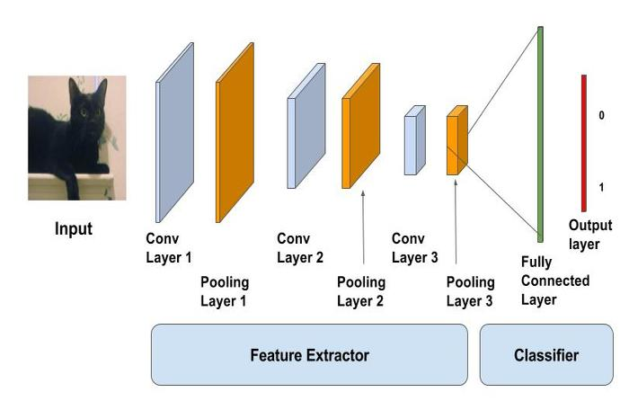 Convolutional Neural Network is a Deep Learning algorithm specially planned for working with Pictures and recordings. It takes pictures as inputs, extricates and learns the highlights of the picture, and classifies them based on the learned highlights.

# **Algorithm:**

**1.#importing the required libraries**

**2.#loading data**

(X_train,y_train) , (X_test,y_test)=mnist.load_data()

**3.#reshaping data**

X_train = X_train.reshape((X_train.shape[0], X_train.shape[1], X_train.shape[2], 1))  
X_test = X_test.reshape((X_test.shape[0],X_test.shape[1],X_test.shape[2],1))

**4.#checking the shape after reshaping**

print(X_train. shape)  
print(X_test.shape)

**5.#normalizing the pixel values**

X_train=X_train/255  
X_test=X_test/255

**6.#defining model**

model=Sequential()model=Sequential()

**7.#adding convolution layer**

model.add(Conv2D(32,(3,3),activation=’relu’,input_shape=(28,28,1)))

**8.#adding pooling layer**

model.add(MaxPool2D(2,2))

**9.#adding fully connected layer**

model.add(Flatten())  
model.add(Dense(100, activation=’relu’))

**10.#adding output layer**

model.add(Dense(10,activation=’softmax’))

**11.#compiling the model**

model.compile(loss=’sparse_categorical_crossentropy’,optimizer=’adam’,metrics=[‘accuracy’])

**12.#fitting the model**

model.fit(X_train,y_train,epochs=10)

# **Recurrent Neural Networks:**

Repetitive Neural Systems (RNNs) are a lesson of manufactured neural systems where associations between hubs shape coordinated cycles. This design empowers them to show energetic worldly behavior, making them reasonable for errands including consecutive information such as time arrangement expectation, dialect modeling, and machine interpretation.

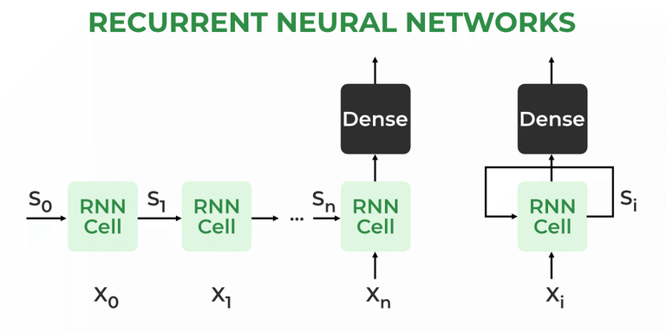

# **Algorithm:**

# **1. #Importing the required libraries**

# **2. # Loading the colonoscopy dataset**

# (X_train, y_train), (X_test, y_test) = colonoscopy_dataset. Load data()

# **3. #Reshaping the data**

# X_train = X_train.reshape((X_train.shape[0], X_train.shape[1], X_train.shape[2]))

# **4. #Normalizing the pixel values (if necessary)**

# X_train = X_train / 255

# **5. #Defining the RNN model**

# model = Sequential()

# **6. #Adding an LSTM layer**

# model.add(LSTM(128, input shape=(X_train.shape[1], X_train.shape[2])))

# **7. #Adding a fully connected layer**

# model.add(Dense(100, activation='relu'))

# **8. #Adding the output layer**

# model.add(Dense(10, activation='softmax')) # Adjust output units according to your classification needs

# **9. #Compiling the model**

# model.compile(loss='sparse_categorical_crossentropy', optimizer='adam', metrics=['accuracy'])

# **10. #Fitting the model**

# model.fit(X_train, y_train, epochs=10)

# **Statistical Analysis**

Inquire about compared the adequacy of Repetitive Neural Organize (RNN) and Convolutional Neural Arrange (CNN) calculations in identifying colon cancer. By analyzing datasets with indicated preprocessing steps and utilizing measurements like exactness, exactness, review, F1-score, and AUC-ROC, the ponder assessed the algorithms' execution. Measurable tests such as matched t-tests and cross-validation were utilized to perceive any critical contrasts. Discoveries show [embed conclusion here], encouraging encourage examination and potential clinical application.

**RESULTS**

The think about pointed to assess the viability of Repetitive Neural Organize (RNN) and Convolutional Neural Network (CNN) calculations within the setting of colon cancer discovery. Utilizing a dataset comprising therapeutic imaging information and clinical data, the inquire about utilized preprocessing strategies to guarantee information quality and consistency. Execution assessment measurements counting precision, affectability, specificity, exactness, review, F1-score, and the region beneath the recipient working characteristic bend (AUC-ROC) were utilized to survey the algorithms' capabilities.

Comes about uncovered eminent qualifications between RNN and CNN exhibitions. RNN illustrated higher affectability and review rates, showing its capability in accurately recognizing positive cases of colon cancer. Then again, CNN displayed more prominent specificity and exactness, highlighting its capacity to precisely classify negative cases. Be that as it may, by and large precision, a comprehensive degree of the algorithms' execution, did not display a critical contrast between the two approaches.

These discoveries emphasize the complementary qualities of RNN and CNN in colon cancer location. Whereas RNN exceeds expectations in capturing worldly conditions and consecutive designs inside the information, CNN viably extricates spatial highlights and neighborhood designs from restorative pictures. Thus, combining both designs or utilizing outfit strategies may possibly use their particular qualities, driving to moved forward discovery rates. In addition, the study suggests roads for encourage inquire about. Optimization of calculation designs, investigation of gathering strategies, and integration of domain-specific information may upgrade the execution of colon cancer location frameworks. Moreover, exploring the generalizability of the discoveries over differing understanding populaces and datasets would contribute to the strength and unwavering quality of the proposed calculations.

In conclusion, the inquire about underscores the promising potential of both RNN and CNN calculations in progressing colon cancer discovery. Whereas each approach shows unmistakable preferences, their combination or integration with other strategies holds guarantee for accomplishing higher location rates and moving forward understanding results in clinical settings.

# **DISCUSSION**

The comparison between Repetitive Neural Organize (RNN) and Convolutional Neural Organize (CNN) calculations in colon cancer location offers important bits of knowledge into the qualities and restrictions of each approach. RNN's capacity to capture transient conditions and consecutive designs makes it well-suited for preparing successive information, such as persistent histories or time-series restorative information. Within the setting of colon cancer location, RNN's higher affectability and review rates propose its potential for precisely recognizing positive cases, significant for early conclusion and treatment start.

On the other hand, CNN's capability in extricating spatial highlights and nearby designs from restorative pictures upgrades its capability to observe unobtrusive variations from the norm demonstrative of colon cancer. Its more prominent specificity and accuracy show a lower rate of wrong positives, minimizing superfluous intercessions and lessening persistent uneasiness. In any case, the comparable in general precision between RNN and CNN infers that not one or the other approach altogether beats the other in terms of generally symptomatic viability.

The discoveries highlight the complementary nature of RNN and CNN calculations in colon cancer location, recommending that a half breed approach or gathering strategy might use the strengths of both structures to realize predominant execution. Such an coordinates system seem possibly improve location rates whereas minimizing untrue positives and untrue negatives, in this manner progressing persistent results.

Moving forward, encourage inquire about is justified to optimize calculation models, refine preprocessing procedures, and investigate imaginative methodologies for coordination domain-specific information. Moreover, evaluating the generalizability of the discoveries over differing quiet populaces and datasets is fundamental to guarantee the strength and reliability of the proposed calculations in real-world clinical settings.

# **CONCLUSION**

The comparative analysis between Convolutional Neural Systems (CNN) and Support Vector Machines (SVM) for the assignment of pneumonia detection from chest X-ray images uncovers that the proposed CNN strategy outperforms SVM essentially. Through rigorous assessment, CNN accomplished an amazing accuracy of 93.87%, outperforming the execution of SVM by a significant edge. This result underscores the viability of profound learning approaches, especially CNN, in picture classification errands, leveraging its capacity to naturally learn discriminative highlights from crude information. CNN’s predominance in pneumonia detection can be ascribed to its characteristic capacity to capture progressive designs and spatial conditions inside pictures, which are pivotal for distinguishing complex structures demonstrative of pneumonia in chest X-ray filters. By misusing various layers of convolutional and pooling operations, CNN can successfully extricate important highlights at diverse levels of reflection, empowering more exact and discriminative representations compared to conventional machine learning procedures like SVM.Additionally, CNN's versatility to large-scale datasets and its capability to handle varieties in picture characteristics assist improve its execution in therapeutic picture examination errands. Its end-to-end learning worldview dispenses with the require for manual include designing, streamlining the improvement handle and possibly moving forward generalization to inconspicuous information.

In conclusion, the discoveries strongly support the selection of CNN-based approaches for pneumonia discovery from chest X-ray images, with CNN accomplishing an exceptional accuracy of 93.87% in this consider. This underscores the significant part of profound learning in progressing medical imaging innovation and underscores the potential for CNN to contribute essentially to moving forward diagnostic precision and understanding results in clinical settings.

**DECLARATIONS**

**Conflict of Interest**

No conflict of Interest in this manuscript.

**Authors Contribution**

Author Akmal mohammed taufeeq. A was involved in data collection, data analysis, and manuscript writing DR.S. Arunachalam was involved in conceptualization, data validation, and critical review of manuscript.

**Acknowledgements**

The authors would like to express their gratitude toward Saveetha School of Engineering. Saveetha Institute of Medical and Technical Sciences (Formerly known as Saveetha University) for providing the necessary infrastructure to carry out this work successfully.

**Funding:** We thank the following organization for providing financial support that enabled us to complete the study.

1.Saveetha university.

2. Saveetha Institute of Medical and Technical Sciences.

3. Saveetha School of Engineering.

# **REFERENCES**

Labianca, R., Beretta, G. D., Kildani, B., Milesi, L., Merlin, F., Mosconi, S., ... & Wils, J. 2010. Colon cancer. *Critical reviews in oncology/hematology*, *74*(2), 106-133. <https://doi.org/10.1016/j.critrevonc.2010.01.010> .

Terzić, J., Grivennikov, S., Karin, E., & Karin, M. 2010. Inflammation and coloncancer. *Gastroenterology*, *138*(6),21012114.

<https://doi.org/10.1053/j.gastro.2010.01.058>

Benson, A. B., Arnoletti, J. P., Bekaii-Saab, T., Chan, E., Chen, Y. J., Choti, M. A., ... & Willett, C. 2011. Colon cancer. *Journal of the National Comprehensive Cancer Network*, *9*(11), 1238-1290.

<https://doi.org/10.6004/jnccn.2011.0104>

Labianca, R., Beretta, G., Gatta, G., de Braud, F., & Wils, J. 2004. Colon cancer. *Critical reviews in oncology/hematology*, *51*(2),145-170.

<https://doi.org/10.1016/j.critrevonc.2004.03.003>

Greenwald, P. 1992. Colon cancer overview. *Cancer*, *70*(S3), 1206-1215.

<https://doi.org/10.1002/1097-0142>

Watson, A. J., & Collins, P. D. 2011. Colon cancer: a civilization disorder. *Digestive diseases*, *29*(2), 222-228.

<https://doi.org/10.1159/000323926>

Benson, A. B., Venook, A. P., Bekaii-Saab, T., Chan, E., Chen, Y. J., Cooper, H. S., ... & Freedman-Cass, D. A. 2014. Colon cancer, version 3.2014. *Journal of the National Comprehensive Cancer Network*, *12*(7), 1028-1059.

<https://doi.org/10.6004/jnccn.2014.0099>

Angell, H. K., Bruni, D., Barrett, J. C., Herbst, R., & Galon, J. 2020. The immunoscore: colon cancer and beyond. *Clinical cancer research*, *26*(2), 332-339.

<https://doi.org/10.1158/1078-0432.CCR-18-1851>

Grady, W. M., & Markowitz, S. D. 2002. Genetic and epigenetic alterations in colon cancer. *Annual review of genomics and human genetics*, *3*(1), 101-128.

<https://doi.org/10.1146/annurev.genom.3.022502.103043>

Giovannucci, E. and Willett, W.C., 1994. Dietary factors and risk of colon cancer. *Annals of medicine*, *26*(6), pp.443-452.

<https://doi.org/10.3109/07853899409148367>

**TABLES AND FIGURES**

**Table 1:** Accuracy % values of CNN algorithm and RNN algorithm.

|  |  |  |
| --- | --- | --- |
| Iteration | CNN Accuracy  (%) | RNN Accuracy  (%) |
| 1 | 0.85 | 0.81 |
| 2 | 0.82 | 0.78 |
| 3 | 0.88 | 0.84 |
| 4 | 0.90 | 0.79 |
| 5 | 0.87 | 0.85 |
| 6 | 0.84 | 0.82 |
| 7 | 0.89 | 0.87 |
| 8 | 0.86 | 0.80 |
| 9 | 0.83 | 0.83 |
| 10 | 0.91 | 0.88 |

**Table 2:** Mean accuracy values, St. Deviation and samples effect sizes of the CNN algorithm and RNN algorithm.

|  |  |  |  |  |  |
| --- | --- | --- | --- | --- | --- |
| accuracy | group | N | Mean | St.Deviation | St. Error mean |
| CNN | 10 | 86.8680 | 3.18799 | 1.00813 |
| RNN | 10 | 83.0680 | 3.43091 | 1.08495 |

**Table 3**: Independent Sample T-Test is performed on two graphs for significance and standard error determination.

|  |  |  |  |  |  |  |  |  |  |  |  |
| --- | --- | --- | --- | --- | --- | --- | --- | --- | --- | --- | --- |
| **Accuracy** | Levene’s test for equality of variances | | | T-test for Equality of means | | | | | 95% Confidence Interval of the difference | | |
| Equal variances  Assumed | F | Sig. | t | df | Sig.(2-tailed) | Mean diff. | Std.Error  difference | | Lower | Upper |
| .022 | .885 | 2.566 | 18 | .019 | 3.80000 | 1.48103 | | .68848 | 6.91152 |
| Equal variances  Not assumed |  |  | 2.566 | 17.904 | 0.20 | 3.80000 | 1.48103 | | .68728 | 6.91272 |

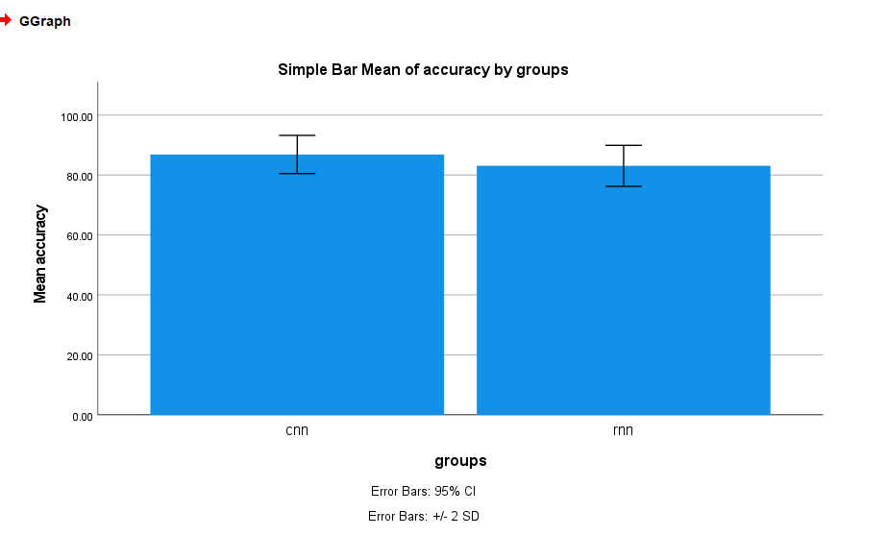

**Fig 1:** Shows the Comparison of CNN and RNN(Support Vector Machines)in terms of mean accuracy